FOR IMMEDIATE RELEASE
World Systems Solutions (WSS) brought together visionary speakers and thought leaders to launch an unprecedented global utility to solve the climate emergency.
Santa Barbara, CA - May 6th, 2023 – At their Spring Gala at the Music Academy of the West, World Systems Solutions, a 501c3 nonprofit organization, introduced the PHOENIX World Transformation Platform, an unprecedented global utility dedicated to the rapid development and delivery of comprehensive solutions to address the climate crisis through a system of artificial intelligence (AI) supported collaboration modules, empowering diverse global stakeholders.
The Gala centered around the PHOENIX platform, currently being designed to aggregate global resources into an organized system for large scale solutions generation and delivery to any area of need in the world. This utility will facilitate the efficient coordination and synchronization of all nations' global climate change efforts and generate scalable, crowd-sourced, AI-supported solutions to regenerate the planet.
The WSS Spring Gala hosted inspiring talks from some of the world’s most visionary speakers, including:
- WSS CEO John Jones, founder and primary architect of the WSS organization and PHOENIX initiative. Jones has dedicated his life to supporting transformational change for humanity to its highest potential. He is the author of Enter the Era of Empowerment, Self- Sovereignty in a Complex World, and A World Without Fear.
- Dr. Katharine Wilkinson, an author, strategist, teacher, and one of "15 Women Who Will Save the World,” according to Time magazine. Her books on climate include the bestselling anthology All We Can Save, The Drawdown Review, the New York Times bestseller Drawdown, and Between God & Green.
- Rev. Dr. Michael Bernard Beckwith, founder of the Agape International Spiritual Center and author of numerous books including Life Visioning, Spiritual Liberation, and TranscenDance, which are the recipients of the prestigious Nautilus award.
Each delivered powerful messages on the climate emergency and the urgent need for greater collective action. The theme of the event was shared with the voices of three complimentary perspectives:
“This is humanity’s moonshot moment to realize its highest collective potentials, and simultaneously to solve the challenges of the climate crisis; and we ask every organization and person that shares this vision to connect and collaborate with us.” - John Jones
“To make all of this possibility reality, science also tells us that we need to implement solutions about 5x faster than we are currently doing. This idea of speed and scale is really vital.” - Dr. Katharine Wilkinson
“A vision without action is fantasy, but an action without vision is chaos.” - Rev. Dr. Michael Beckwith
Participants were greeted with an evocative conservation wildlife art gallery by Gamini Ratnavira which complemented the event's theme of sustainability and biodiverse environmental stewardship. Master Wildlife Artist Gamini Ratnavira has exhibited species from 55 countries and has sold his artwork at Christie’s, Sotheby’s and Bonham’s Art auctions. In addition, Ratnavira has exhibited in the National Geographic Society’s Sculpture Garden in Washington D.C.
Attendees included influential leaders from climate, conservation, academia, the arts, spirituality and several organizations representing women, youth and diversity. The evening featured the Brothers Koren, who provided moving musical interludes, collaborating with the audience on a song that gave voice to the inspiration of the evening. Thorald and Isaac Koren are leaders in expanding creative expression with over 20 years as teachers, performers, and transformational leaders.
WSS communicated as an organization, their commitment and strategy for empowering and educating the world’s youth, women and diversity on the PHOENIX platform to generate solutions together. WSS’s next event will be the Youth Climate Action Summit, later this year. In addition, the organization is preparing to launch the first PHOENIX platform, ClimateScale, empowering humanity to resolve climate change through easy access to greenhouse gas offsets, investments and donations.
The Gala was generously sponsored by Dr. Nancy O’Reilly, Women Connect4Good, Anya and Larry O’Reilly, Hidden Forrest Art Gallery, and Strange Family Vineyards.
The focus of the evening was the sense of collective purpose and commitment to revitalizing our planetary systems into a sustainable world for future generations. The event stressed that this is THE moment for humanity; that we are at an inflection point in our evolution, and collectively, we are designing the necessary tools that can be applied globally; only now has it become possible for humanity to apply its co-creative capacity in an organized way to transform itself to reach its potential.

Press Contact:
Strategic Partnerships Team
World Systems Solutions
worldsystemssolutions@wssnow.org
www.wssnow.org
(844) WSS-NOW1

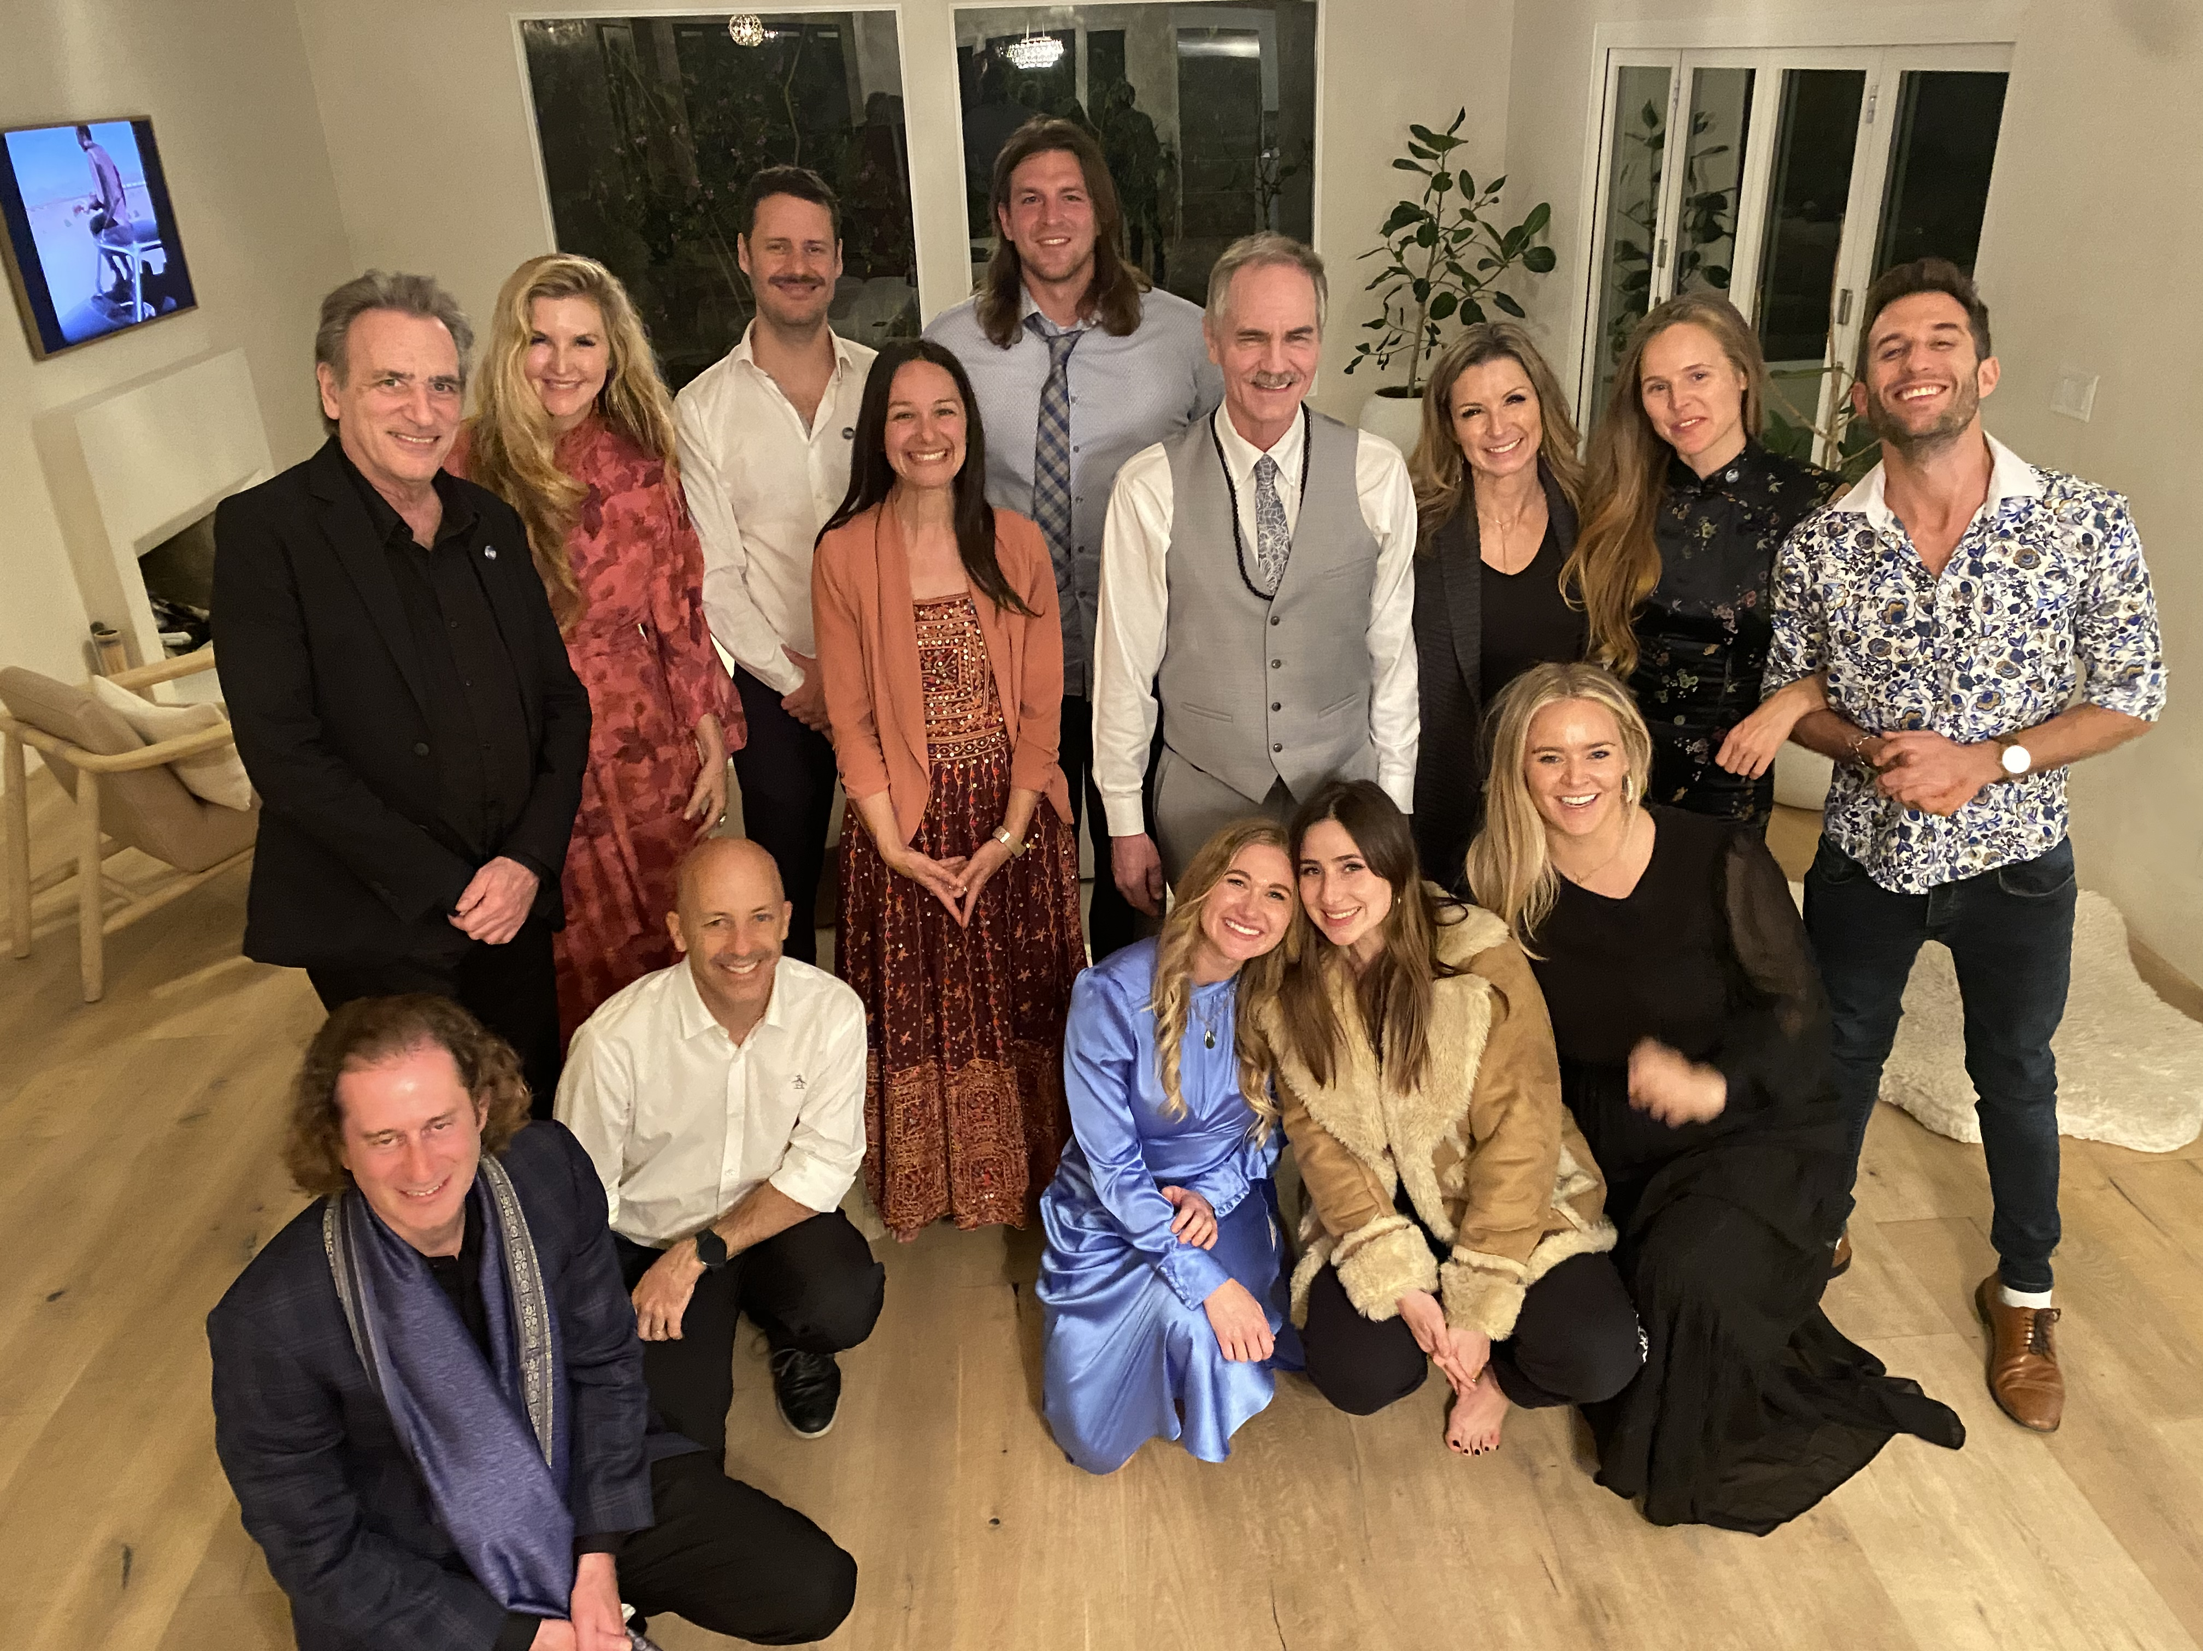
Members of the World Systems Solutions Team


The Hidden Forest Art Gallery by Gamini Ratnavira at the World Systems Solutions Spring Gala at Music Academy of the West

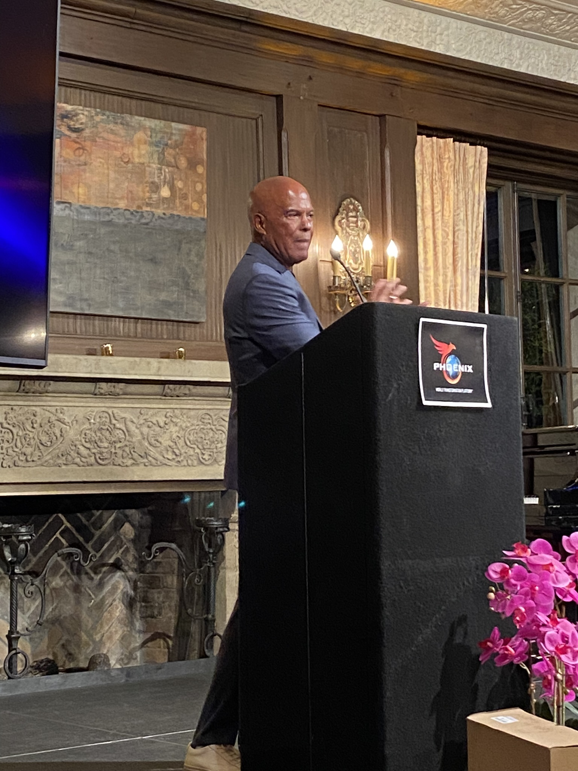
Dr. Reverend Michael Beckwith Presenting

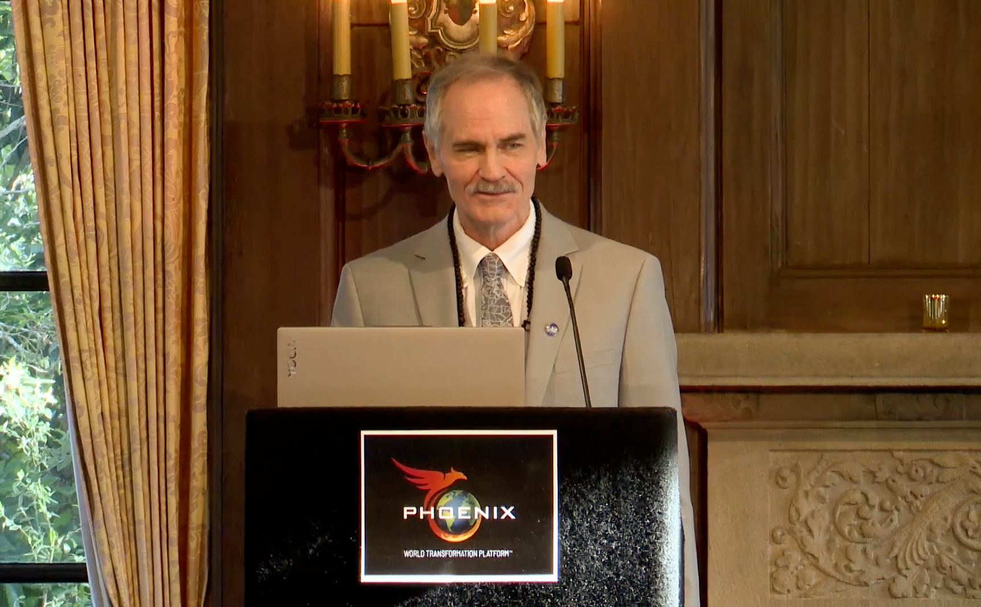
WSS CEO Presenting PHOENIX World Transformation Platform

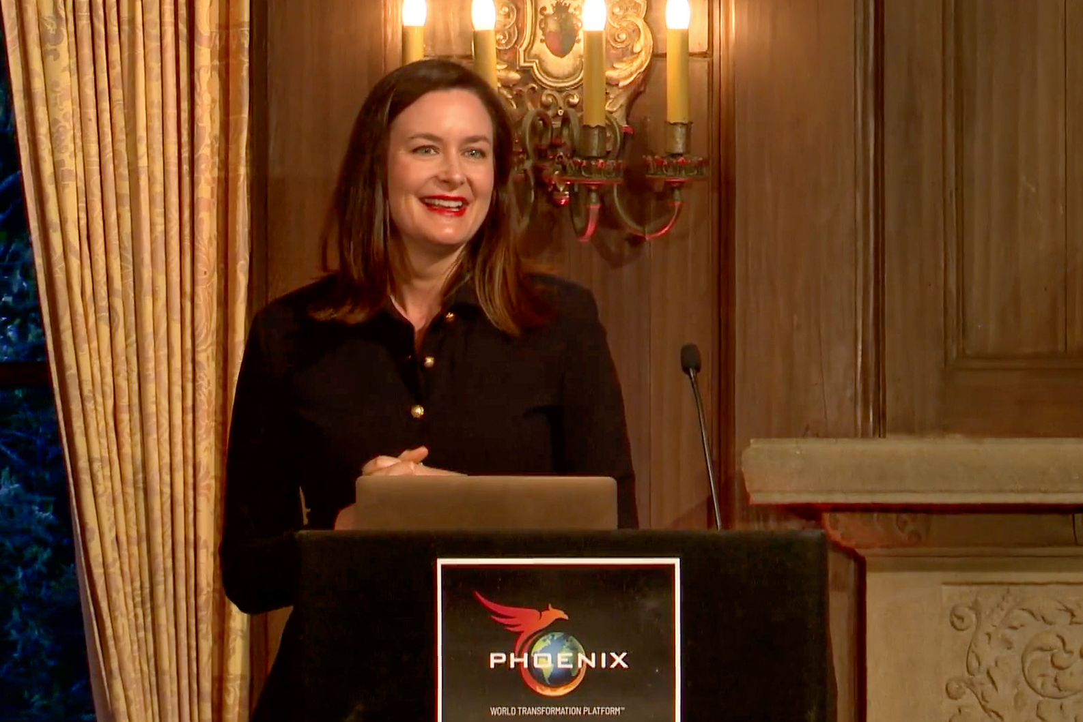
Dr. Katharine Wilkinson Presenting

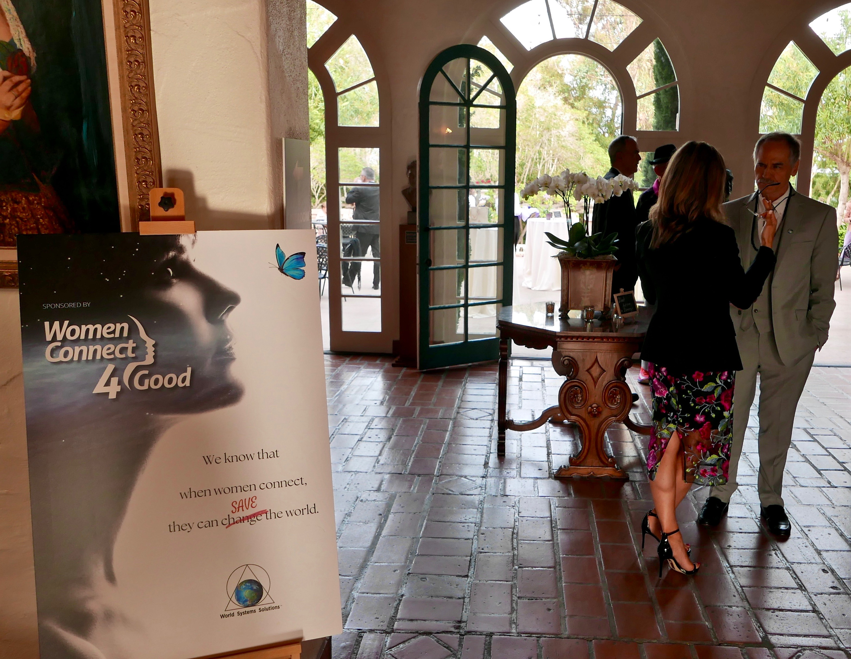
The World Solutions Spring Gala was sponsored by Women Connect4Good

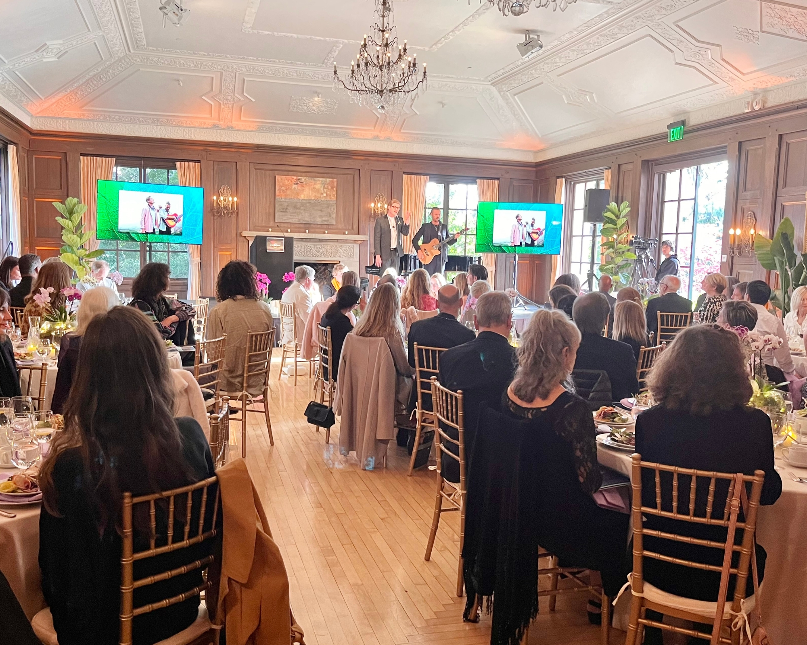
The WSS Spring Gala

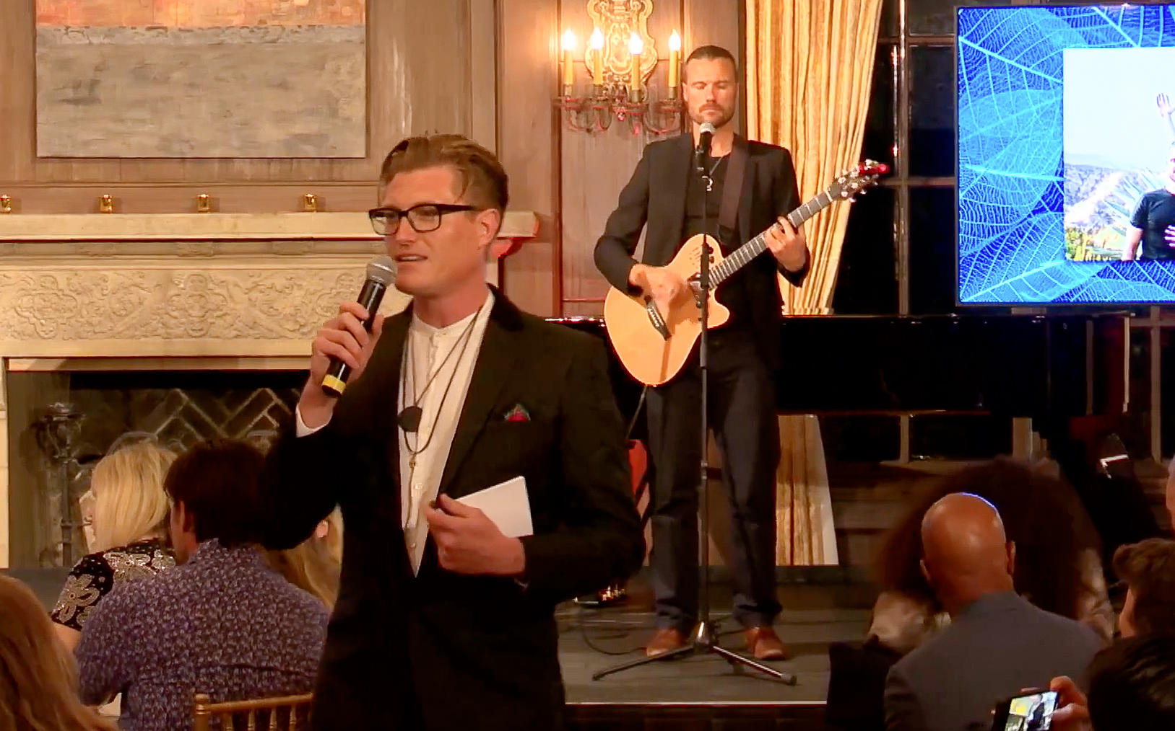
The Brothers Koren

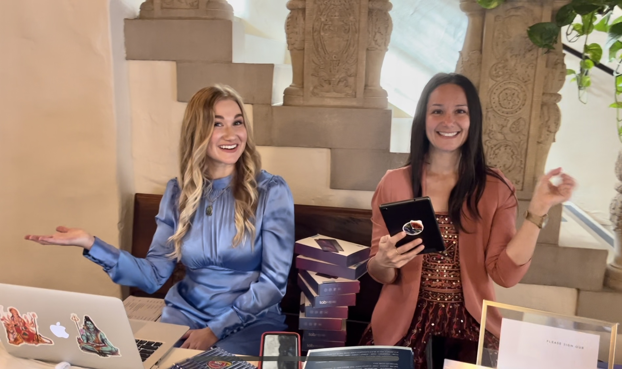
Welcome to the WSS Spring Gala

